Important Dates:

Peer Review (class) - Tuesday May 7

Final paper due - Monday May 13 @ midnight

Project description

* The final project will be to discuss and perform a group of statistical analyses. Both the scientific and statistical background should be clearly presented, and future statistical steps you plan to take.
* These should be written and presented like the results section of a scientific paper, with a **full ABSTRACT**, very brief introduction with a background/hypotheses, methods, and discussion section sufficient for understanding the results.
  + It is acceptable to use the previously written paragraph about your data as background.
  + Bullet points in the introduction, methods, and discussion section are acceptable. You should think of this an outline of a thesis paper.
  + Usually, we flesh out the results and the figures, then add the rest of the stuff. I write my abstracts as a mini-outline that helps me figure out what should go in each section.

What to turn in:

1) Your full "paper" with figures, tables, captions embedded in the text, and any appendices that you might put in the supplemental online material.

2) All of your code, completely reproducible, committed and pushed to Github.

3) If more than one file is used to make the code, LANGWIG_FINALPROJECT_README file that tells me how your code goes together.

Drivers of Intrinsic Rarity and Climate Sensitivity in Freshwater Fishes of the Contiguous United States

Sam Silknetter, Abigail Benson, Jennifer Smith, Meryl Mims

**Introduction (background, hypotheses)**

* Risk assessments – used to understand species’ risk to global change
* Freshwater fishes are disproportionally imperiled
* Publically available data (GBIF, IchthyMaps, FishTraits, etc..) can be leveraged for broadscale analyses like this one
* Used point occurrences for freshwater fishes of the U.S. to classify them based on:
  + Area of occupancy (AOO), which reflects grain size and geographic extent; values range from 0-1
  + Climate sensitivity (CS), which reflects the composite breadth of historical climate conditions associated with the range size (AOO) of each species
* AOO and CS combine to create a rarity and climate sensitivity (RCS) index
* 4x grain sizes for AOO, which results in unique CS and RCS values for each scale

Hypotheses:

1. RCS values are most variable at intermediate range size as a result of AOO values which follow the same pattern
2. RCS values are correlated with life history traits and conservation status of freshwater fishes

**Methods (scientific and statistical)**

* Species selection process (talk through, what is necessary?)
* See the figure below and maybe it is self-explanatory?

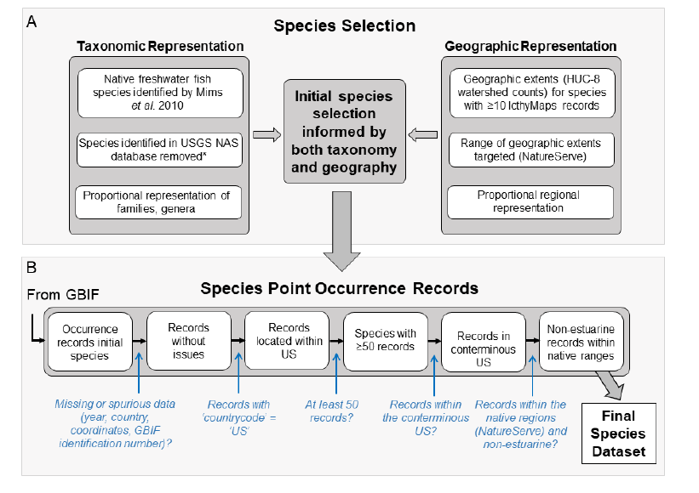

**Results**

* From assignment 10/11:

A generalized linear modeling approach was used to examine the relationship between rarity and climate sensitivity values (RCS, and index between 0-1 with higher values indicating greater sensitivity) for ~120 freshwater fish species and a suite of biologically relevant predictors. The RCS response variable was beta distributed, and as such all models were conducted using betareg() function (package betareg, R Core Team 2019). Predictors used included log transformed maximum total length (MAXTL) and area of occupancy (AOO, a measure of a given species geographic extent). Results indicate that RCS values are negatively correlated with MAXTL and AOO, suggesting that species with larger range sizes are buffered from the greatest threats to freshwater fishes, especially when they are large-bodied. While MAXTL alone explained little of RCS variation (pseudo-R² = 0.106, Z(3, 120) = -3.696, p = .0002), the model with MAXTL and AOO as additive predictors yielded substantially greater explanatory power (pseudo-R² = 0.611). By fitting predicted values at four values of AOO (0.05, 0.25, 0.5, 0.75), we can observe the effects of MAXTL with AOO held constant. As can be seen in Plot 3 (output of Line 53), reductions in RCS values correspond to increased MAXTL as well as increased AOO.

* Results (fully written like a scientific paper). Please re-visit tips for writing results sections from the lecture.
  + Please put figures in this section of paper with their captions directly below them.
  + Include statistical results as 1) either in the text, 2) in main text tables, or 3) as supplemental tables as you would in a real paper.

**Discussion (what do your results mean, future statistical analyses to be conducted, what this tells us about the world)**